**Name:** V Venkata Sri Prasad

**Batch:** Data Engineering

**Date:** 30/01/2024 – (Day 9)

Topics

1. File IO using Python
2. Read Data from CSV File into Python List
3. Processing Python Lists
4. Lambda Functions in Python and Using lambda() Function with map(),filter(),reduce()

**Use of Lambda Function in Python:**

**Lambda functions:** are concise, anonymous functions defined using the lambda keyword. They are employed for short-lived operations where a full function definition might be overly verbose.

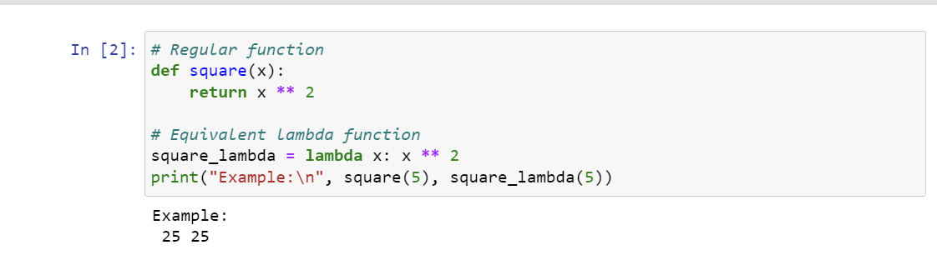

**Practical Uses of Python Lambda Function:**

Lambda functions are practical for short-lived tasks where a full function definition might be verbose. They are commonly used within higher-order functions like map(), filter(), and reduce().

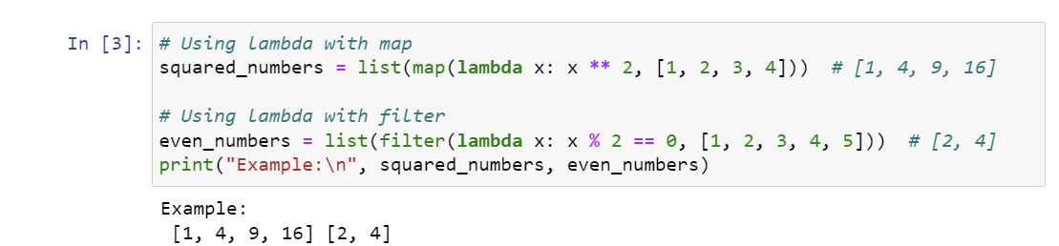

**Using lambda() Function with map(), filter(), reduce():**

Lambda functions seamlessly integrate with higher-order functions like map(), filter(), and reduce(), providing a concise way to define operations for processing iterables.

**map():**

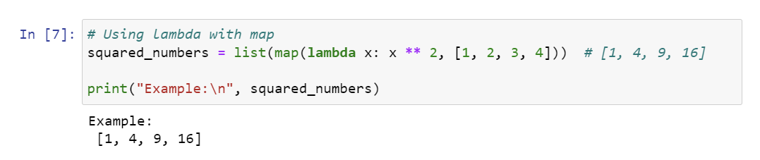

Filter():

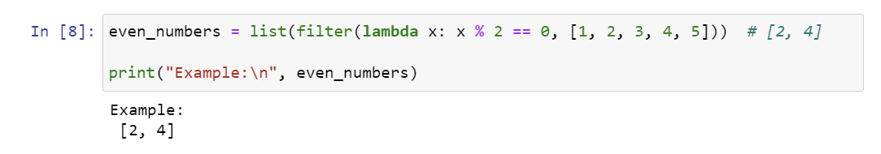

Reduce():

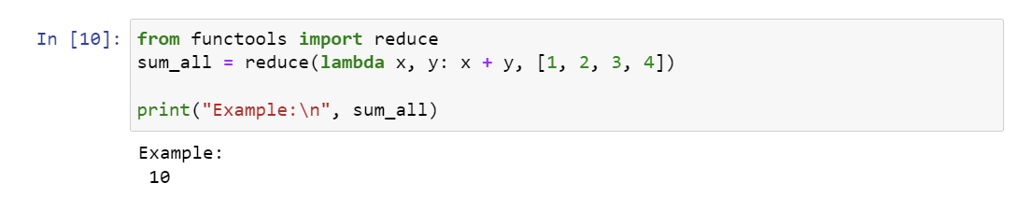

**Processing Python Lists in python**

Processing Python lists involves performing various operations on the elements of a list to achieve a specific outcome. Here are some common operations and examples:

**List Comprehension:**

List comprehensions provide a concise way to create lists and perform operations in a single line.

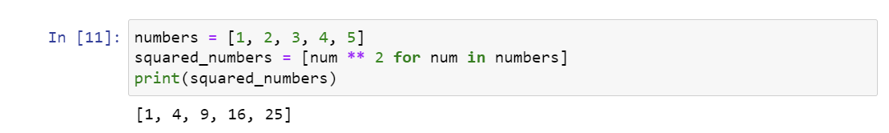

**File handling**

**File IO using Python**

Python provides the open() function to handle file input and output. You can use it to open a file, read or write data, and close the file afterward. For example, to read data from a CSV file:

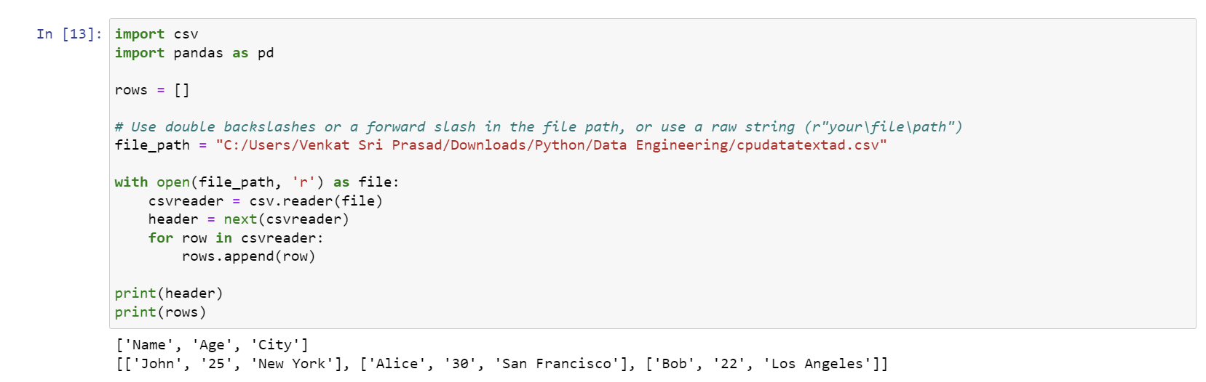

**Read,Write,Append:**

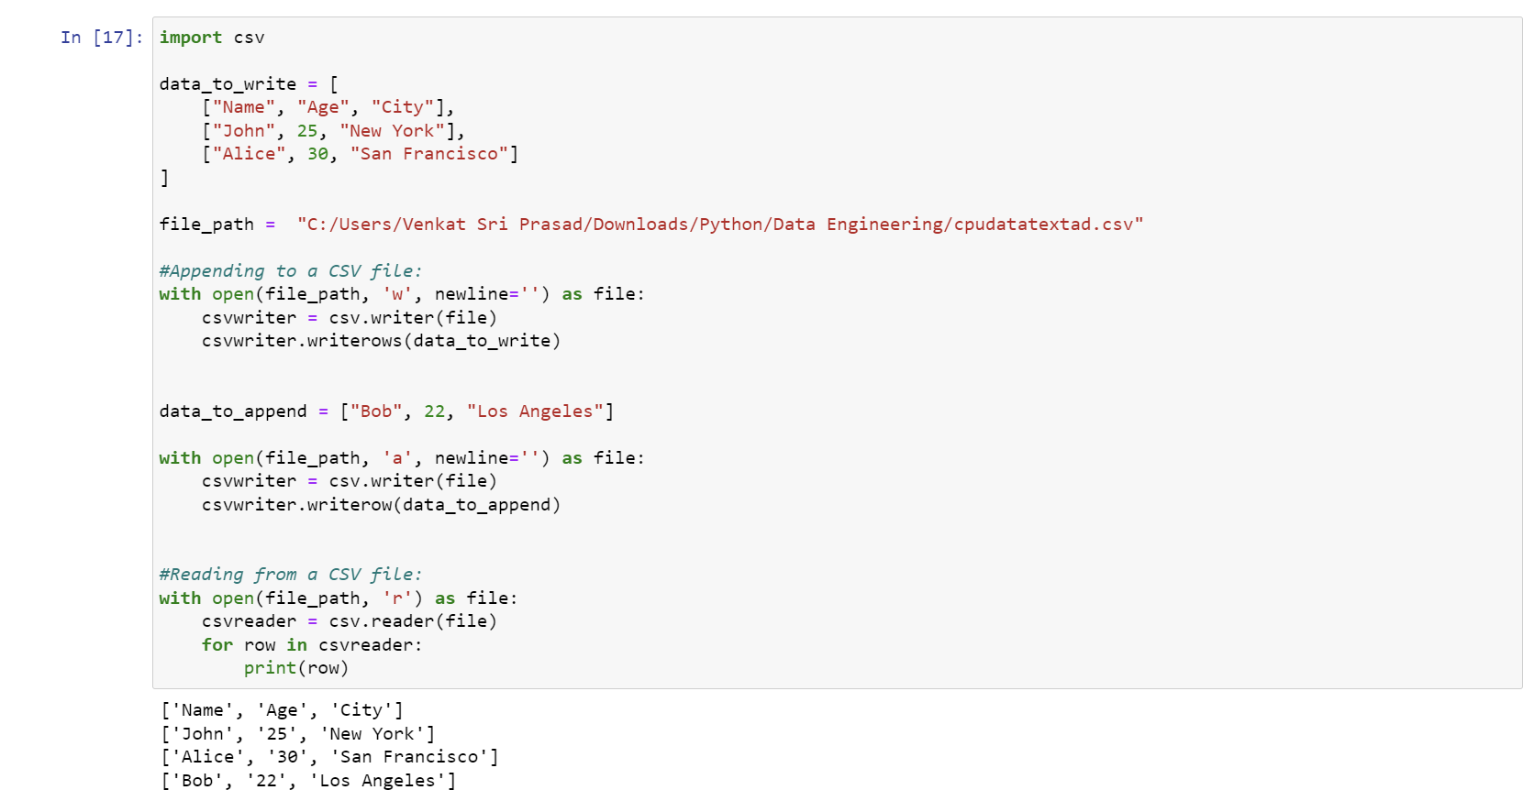

**Using Pandas:**

Pandas is a powerful library for data manipulation and analysis in Python. It provides easy-to-use functions for reading, writing, and appending data in various formats, including CSV, Excel, and more. Here are examples using pandas:

